

Propellor calculation test plan

Propulsion system simulation

Fangzhou chen Jiacong li Marco Hoogesteger Martijn Crombeen

*Organisation: Solar Boat Sealander*

*Client: Mr. R. Eijlers*

*Tutor: Mr. W. Haak*

*Date: 23-11-2020*

2020

Table of content

1. Aim & Hypothesis 2

1.1. Aim 2

1.2. Hypothesis 2

2. Variables 2

2.1. Inputs 2

2.2. Outputs 2

3. Tools 3

4. Method 3

4.1 Steps 3

5.Expect result 3

6.Conclusion 3

7.Appendix 4

Explanation 4

Formulas 4

Propeller characteristic curve 4

Thrust coefficient 4

Torque coefficient 4

General thrust formula 5

Power output 5

# Aim & Hypothesis

## Aim

The aim of this test is to verify the simulated mathematical model of the propellor calculations.

## Hypothesis

The propellor simulation has the same output as the calculations.

# Variables

These are the constants and variables that will be used during the test.

|  |  |
| --- | --- |
| Constants simulation | Keep constant at... |
| Battery level computer | Constant power source. |
| All input variables | Real positive numbers & ISO-notation. |

## Inputs

The limits stated are the limits of the real world. If values out of this range are entered, the outputs will be unreliable.

|  |  |
| --- | --- |
| Inputs | Value |
| Power input [W] | 0 - 8400 |
| Rotating speed [rpm] | 0 - 2200 |
| Torque input [Nm] | 0 - 3500 |
| Propellor diameter [m] | 0,1 - 0,5 |
| Propellor coeffcient Kt | 0,47 |
| Propellor coeffcient Kq | 0,065 |
| Liquid density [kg/m3] | 980 - 1000 |
| Channel area [m2] | 5*10-3 - 1 |

## Outputs

These are the outputs that will be monitored and will be used to see variations or changes in the system.

|  |  |
| --- | --- |
| Outputs | Value |
| Thrust [N] | 0 - 500 |
| Torque error [Nm] | 0 - 3500 |
| Power output [W] | 0 - 8400 |
| Power loss [W] | 0 - 8400 |
| Rotational speed propeller [rpm] | 0 - 2200 |

# Tools

|  |  |
| --- | --- |
| Testing tools | Demand |
| Computer | Windows 10 compatible |
| Excel | Newest version |
| Keyboard | No limit |
| Mouse | No limit |
| Calculator | Basic calculator |
| Pen & Paper | Basic pen & paper |
| Mathematical model | Using correct formulas |

# Method

The simulation will be compared to the actual calculations to see if they are the same.

## 4.1 Steps

1. Put the different values from 2.1 in the simulation
2. Note the outputs
3. Calculate the outputs based on the mathematical model (7.Appendix) using pen, paper and calculator
4. Note the answers.
5. Compare the two answers.

# 5.Expected results

The expected outputs are according to the mathematical models and between the range stated in the table 2.2

# 6.Conclusion

If the outputs have the same values as their calculated counterparts, the test is considered as passed.  
If not, the test is considered as failed.

# 7.Appendix

## Explanation

The experiment of propeller alone in uniform water flow is called open water experiment. The following formulas and coefficients can be applied in these circumstances.

## Formulas

### Propeller characteristic curve

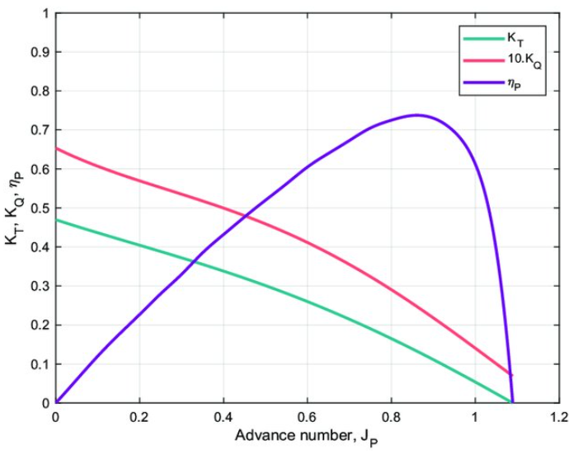

Figure 1 Example curve

The thrust coefficient and torque coefficient are inversely proportional with the advance ratio. When $J=0$ (speed is constant), the thrust and torque coefficients reach their maximum values.

### Advance coefficient

$$J_{v }=\frac{Va}{n*d}$$

Jv = Advance coefficient

Va = inflow stream velocity (m/s)

N = rotational velocity (rev/s)

D = propellor diameter (m)

### Force equilibrium (speed is constant)

$$Ft=Fr$$

Ft = thrust (N).

Fr = resistance (N).

### Resistance force

$$Rtotal=\left(1-t\right)*Fr$$

Rtotal = total boat resistance (N)

T = thrust deduction factor

Fr = resistance (N).

### Thrust coefficient

$$K_{T}=\frac{Ft}{ρ×n^{2}×d^{4}} → Ft=ρ×n^{2}×d^{4}×K_{T}$$

Ft = thrust (N).

$ρ$ = liquid density (${kg}/{m^{3}}$).

n = rotating speed (rev/s).

d = diameter (m).

$K_{T}$ = thrust coefficient.

### Torque coefficient

$$K_{Q}=\frac{Q_{R}}{ρ×n^{2}×d^{5}} → Q_{R}=ρ×n^{2}×d^{5}×K_{Q}$$

*QE = QR – QI*

= torque difference(Nm).

$Q_{R}$ = torque required (Nm).

$Q_{I}$ = torque input (Nm).

$ρ$ = liquid density (${kg}/{m^{3}}$).

n = rotating speed (rev/s).

d = diameter (m).

$K_{Q}$ = torque coefficient.

### Power output

$$P=F×v$$

P = output power (W)

F = force (N)

v = velocity(m/s).

### Power input

$$P=T×ω$$

P = input power (W)

T = torque (Nm)

ω = radial velocity (rad/s).

### Stream velocity

$$Va=(1-w)×Vb$$

Va = inflow stream velocity (m/s)

Vb = boat speed (m/s)

W = wake fraction

### Propellor efficiency

$$η=(Ft*Va)/(n*Q)$$

Ft = thrust (N)

Va = inflow stream velocity (m/s)

N = radial velocity (rad/s)

$Q_{R}$ = torque required (Nm).

### Propulsive efficiency

$$η=(Rtotal*Vb)/(n*Q)$$

Rtotal = total boat resistance (N)

Vb = boat speed (m/s)

N = radial velocity (rad/s)

$Q_{R}$ = torque required (Nm).